Dear Residents,

During these hot and humid months, please stay hydrated. If you did not receive a water bottle from Aquarion, please get one from Heather or Daisy.

Mold Prevention
Preventing mold is the responsibility of every tenant. You will find a How to Prevent Mold sheet attached to the newsletter. Please put it on your refrigerator. Mold comes from humidity and water. -You MUST clean up spills and keep the vent in your bathroom running when you take a shower and when you are boiling water or cooking on your stove. There are several household products you can purchase to kill mold. Mold prevention is your responsibility. If you see it, clean it. It can spread rapidly.
-White mold appears on wood, like the inside and outside of your cabinets.
-Black mold appears on walls, sinks, bathroom, ceilings, carpeting, and the like.
IF YOU HAVE MOLD IT IS YOUR RESPONSIBILITY TO CLEAN IT.
-Maintenance will be doing periodic mold checks and you will be alerted by our RoboCall system when to expect them. You do not have to be home for this.

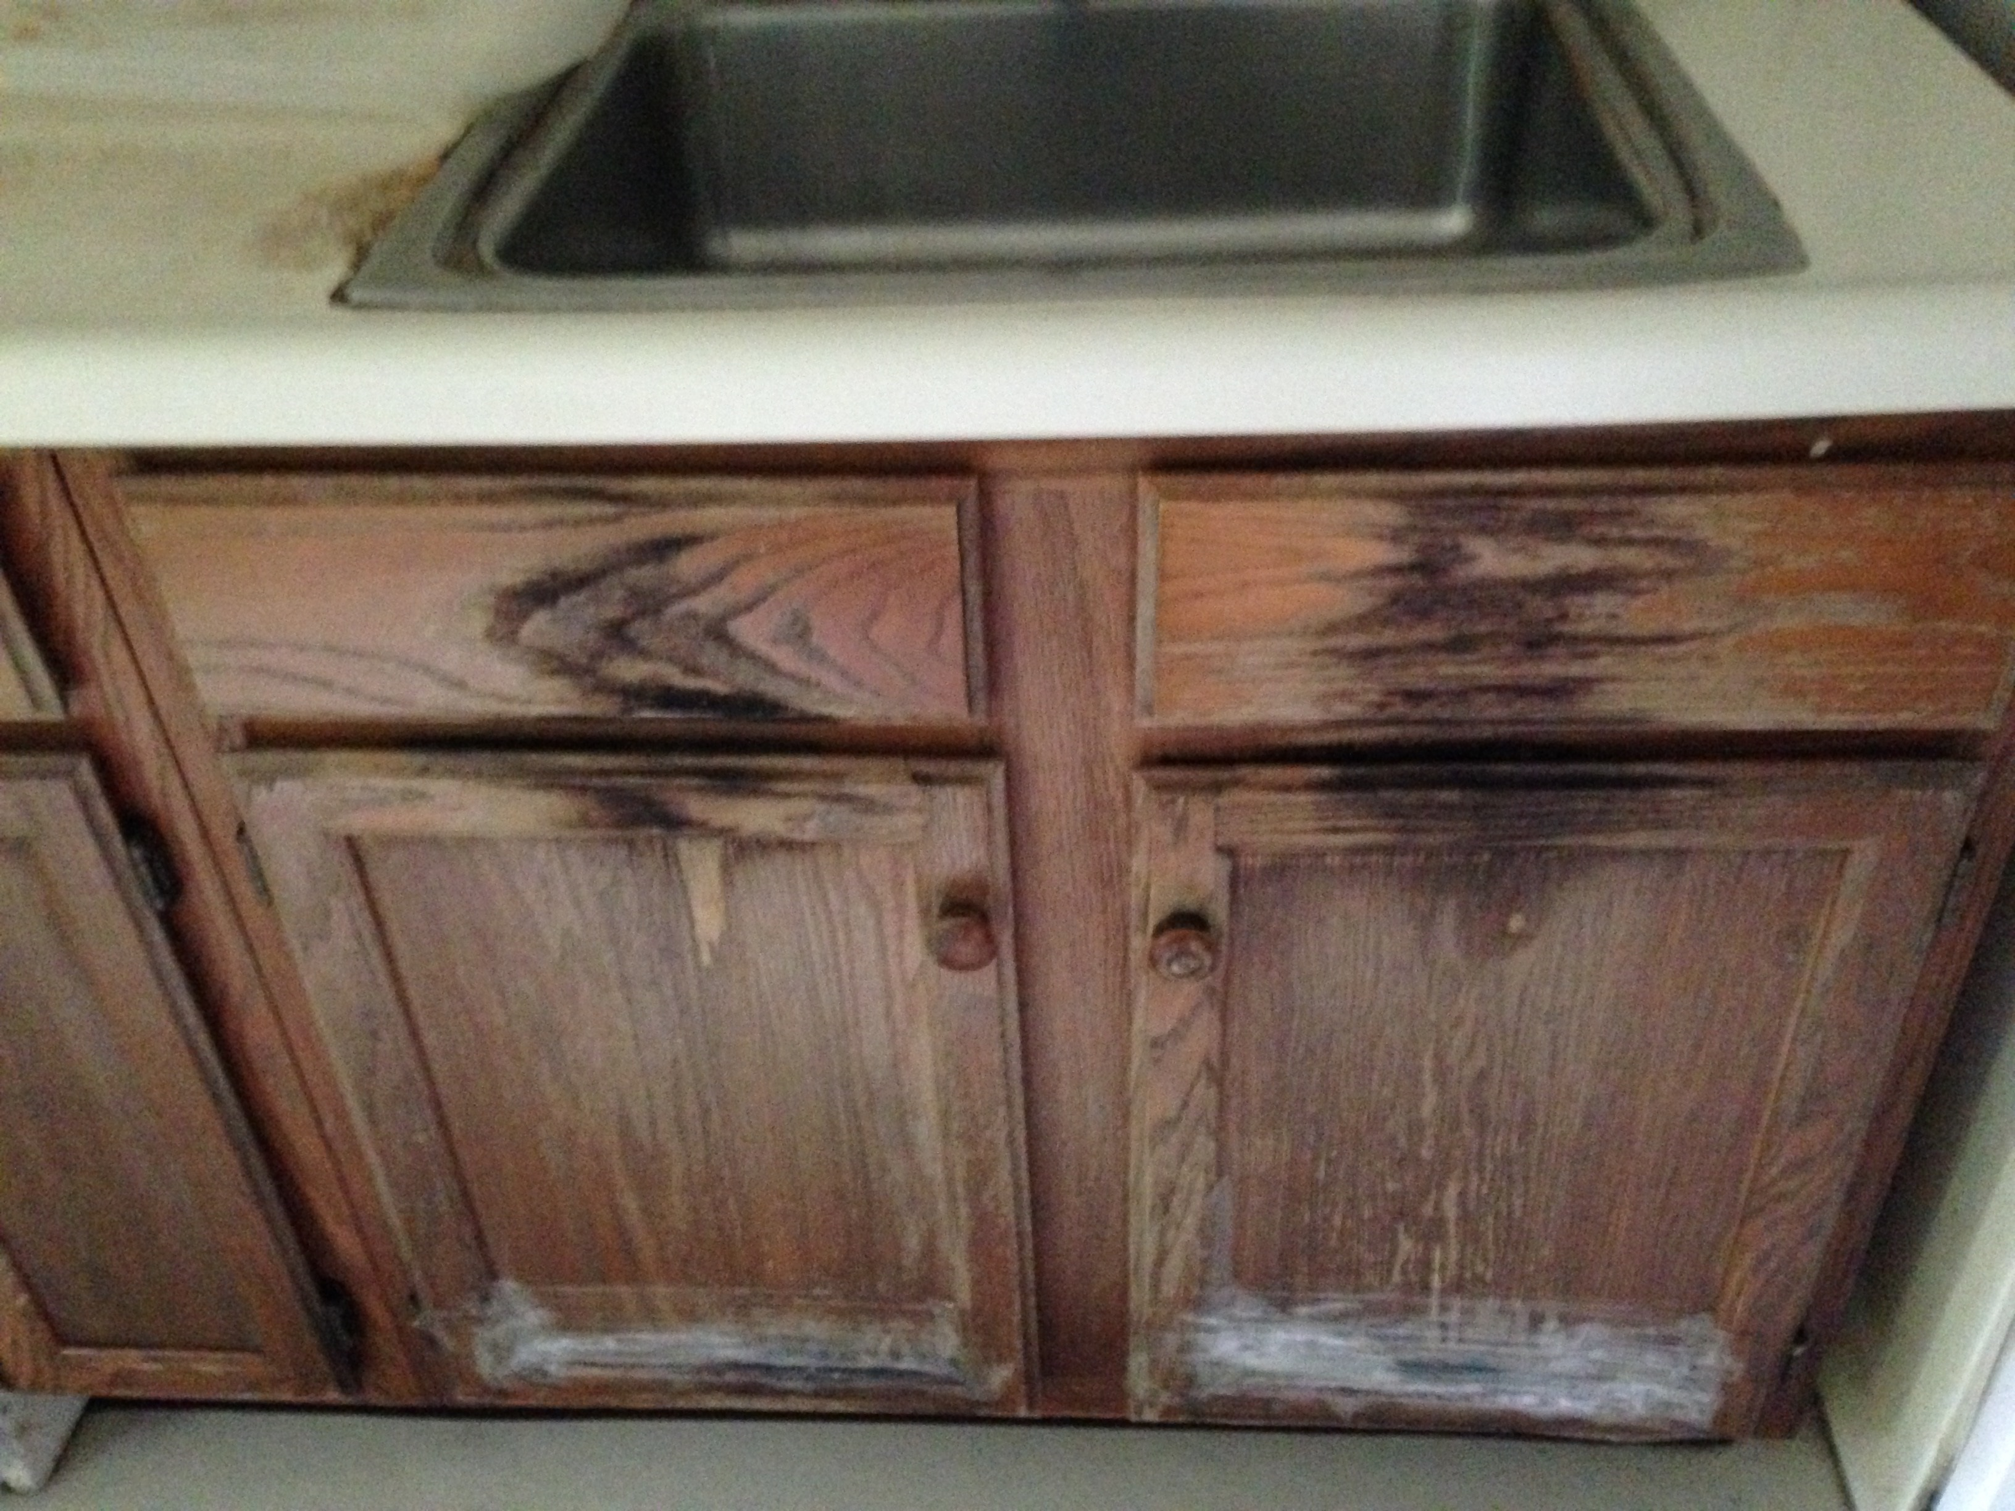
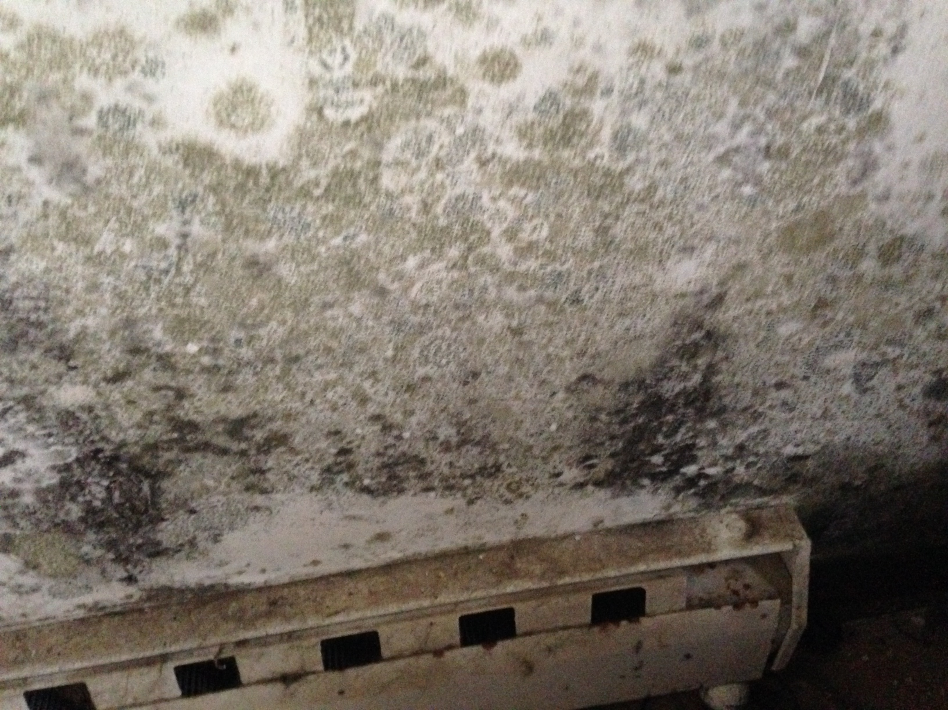

Outside Spigots
If a spigot does not have a handle, it is broken. Do not try to use it!
If you have a question about a spigot, please call the office.

Welcome to the THA Family
We have several new residents moving to Stern Village and the Congregate. Please welcome them to our amazing and vibrant community. Get to know your new neighbors.

New Pool Table
We have a new, regulation pool table in the Community Room. Please join the fun!

Thank you for all you do to make Stern Village “The Jewel of Trumbull”. We have several residents who truly care about their neighbors and our community.
My door is always open to you.

Enjoy the warm weather.

Harriet

Trumbull Police
If you see it, say it. You can always call the non-emergency number for the Trumbull Police
203-261-3665.

IMPORTANT DATES
Stern Village Resident Association Meeting
Tuesday, August 1, 2017
10:00 am
Community Room

Harriet’s Tuesday Tea
Tuesday, August 22, 2017
10:00 am
Community Room
Meeting for all THA residents
Refreshments will be served

THINGS YOU SHOULD KNOW

GOLF CART
The golf cart is now in use for those residents that wish to get rides to activities, such as Bingo, and the hair salon. If you need a ride, call Heather at 203-261-5740 X 1.

LOCKED OUT?
If you lock yourself out of your apartment when the THA office is open, you MUST call the THA Office only, at 203-261-5740. The attendants at the Congregate will no longer be available to open your doors! You must be responsible to remember your keys at all times.

NURSE’S MONDAY HOURS
Community Room - 8:30 am -11:30 am
Congregate Building–11:30 am - 3:00 pm

BEAUTY SALON - Located in the Village
Sheila: 203-913-3798
Tuesdays & Wednesdays
11:00 am – 2:00 pm
Betty: 203-234-2354
Fridays by appointment only
10:00 am – 2:00 pm

EMAILS-Additional Contact Info
If you have an email address, please fill out the form attached to this newsletter and bring it back to the office.

TRUMBULL SENIOR CENTER MEMBERSHIP & TRANSPORTATION
The Trumbull Senior Center provides transportation for Trumbull residents, age 60 and over and/or age 55-59 if disabled, along with their caregivers. Rides are offered Monday thru Friday between 9:00 am – 3:00 pm. Rides are for those traveling to and from the senior center, medical and legal appointments, and grocery shopping.
Rides to Stop & Shop are available on Tuesdays. Limit of 3 grocery bags per person.
For reservations call Ashley at 203-452-5137. It is recommended that you call 2 weeks in advance. Riders must register with the center by filling out a membership application. It is $5 a year to register. Our drivers can bring the registration form for first time riders on their first ride or it can be downloaded on the town's website at www.trumbull-ct.gov.

PARKING
Visitors should park by the Congregate or on the right side of the road before the stop sign as you enter Stern Village.
-All Aides MUST park by the Congregate and walk.
-If you do not have a THA Parking Sticker prominently displayed, you will get a written notice to move your vehicle.
-Vehicles that are not registered, have no marker, do not have a THA sticker, and/or look abandoned will be towed at owners’ expense
There are no assigned spots for resident parking.
- Please be considerate of those residents who have difficulty walking or breathing.

SPECIAL THANKS
A special thank you to the following individuals for their generosity:

Thank you to Ranea Werthman and Maria Sienkiewicz for donating plastic bags.

Thank you to Fernando Moura for setting up and playing the movie on movie nights and for cleaning up after the movie.

Thank you to Joe Fiore, Victor Vallario, John Vogele, and Gus Aquino for helping Paulette on Bread Day.
WEEKLY ACTIVITIES
Monday
Bingo-1:30 pm in the Community Room

Tuesday
Chair Exercise with Romy-10:30 am in the Congregate TV Room
Pinochle-1:30 pm in the Community Room
Rosary-1:30 pm in the Congregate TV Room
Pokeno-1:00 pm in the Community Room

Wednesday
Bingo-2:00 pm at the Congregate Building

Thursday
Adult Coloring-10:00 am in the Community Room
Chair Exercise with Romy-10:30 am in the Congregate TV Room
Game Night- 6:00 pm in the Community Room

Friday
Yarn Arts-10:30 am in the Congregate Crafts Room (2nd Floor)
Mass-1:30 pm in the Congregate Dining Room every 2nd Friday of the month
Bingo–2:00 pm in the Congregate Building
Movie Night- 6:00 pm in the Community Room

MONTHLY ACTIVITIES
Stern Village Resident Association Meeting
Tuesday, August 1, 2017
10:00 am
Community Room

Musical Entertainment With Patsy Shore
Tuesday, August 1, 2017
2:00 pm
Congregate Dining Room

Pianist and Entertainer Joe Travarelli
Thursday, August 3, 2017
2:00 pm
Congregate Dining Room

Arts & Crafts With Allison
Monday, August 7, 2017
10:30 am
Congregate Crafts Room (2nd Floor)

Musical Entertainment With Lynn Lewis
Thursday, August 10, 2017
2:00 pm
Congregate Dining Room

Arts & Crafts With Allison
Monday, August 14, 2017
10:30 am
Congregate Crafts Room (2nd Floor)

Musical Entertainment With Tony Castle
Tuesday, August 15, 2017
2:00 pm
Congregate Dining Room

Harriet’s Tuesday Tea
Tuesday, August 22, 2017
10:00 am
Community Room
Refreshments will be served

Musical Entertainment With Lynn Lewis
Thursday, August 31, 2017
2:00 pm
Congregate Dining Room

HOUSEKEEPING
Resident Barbara Lucas is available for light housekeeping. If you are interested you can call her at 203-638-4907.

NEW MAIL CARRIER
As you know we have a new mail carrier. He is learning the route. Please be patient!

