Stern Village and Stern Center

CHFA # 85195D

Trumbull Housing Authority

CHFA
Capital Needs Assessment and
Project Scope Narrative

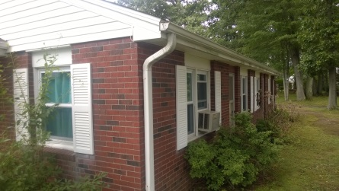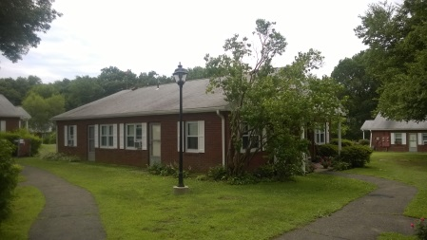

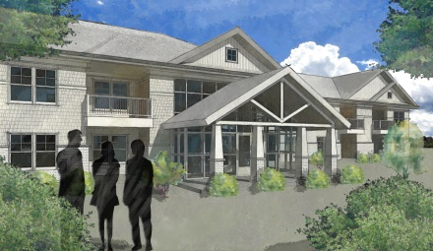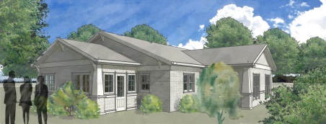

April 15, 2105

Trumbull Housing Authority
200 Hedge Hog Circle
Trumbull, Ct 06611

Attn: Harriet Polansky, Executive Director

Dear Harriet:

Pursuant to your request for us to provide the Trumbull Housing Authority with a brief narrative discussion of the Capital Needs Assessment Analysis as compared to the current project scope we would like to provide the following information for your information.

- Executive Summary
  - While the CNA Analysis is a valuable tool to forecast capital needs it is not designed to address deep concerns about the actual viability & quality of life as well as health & safety issues of Stern Village. Other supportive assessments point to a grim forecast for Stern Village. They conclude Stern Village cannot sustain itself and will require additional heavy Government funding to continue in the foreseeable future. Stern Village needs a comprehensive revitalization to increase the Net Operating Income and insure its viability as an attractive affordable Senior Housing Aging in Place alternative in a Community lacking affordable housing choices.
  - The CNA report dated March 7, 2013 prepared by On Site Insight was a comprehensive study as to what would be required to maintain Stern Village in an “as is” scenario. The report was not an in depth investigation of the unique conditions that exist on the Stern Village campus. There were additional findings not addressed by the CNA, which could only be discovered by an in-depth on site investigation. These additional findings have a substantial impact on increasing the costs associated with the March 7, 2013 CNA.
  - The CHFA Capital Plan Property Assessment - Stern Village prepared by Recap Advisors, LLC identifies several possible scenarios to sustain Stern Village over time. The conclusion of the assessment is that “This property does not have a stable operating revenue and expense picture and is at-risk”
  - The CHFA Market Assessment prepared specifically for Stern Village concluded the two marketing drawbacks to the complex are the small size of the units – particularly the one bedroom - and the concentration in studio units.
  - These Assessments motivated the Trumbull Housing Authority to examine long term options to ensure the sustainability of Stern Village.
  - During the design process, it became apparent that there are several health, safety and quality of life issues beyond the CNA that needed to be addressed, in order to improve the sustainability of Stern Village.
    - Feasibility of increasing the existing unit size.
    - Improve site access
    - Correct chronic Sanitary Sewer problems exist apparently as a result of converting from septic to sewers more than 20 years ago without seemingly updating piping materials.
    - Address the Storm Water Sewer deficiencies that are currently creating unsafe flooding condition in roadways and pedestrian walkways. This is especially acute in the areas where previously filled wetlands existed and was improperly filled 35 years ago.
    - It was noted that health and safety drove the decision to create improved site access (both from a resident need and first responder). That necessitated the loop road, increased parking and the need to construct replacement units.
    - Trumbull Housing Authority’s health, wellness and safety services and programs initiated the need for improved community space including a wireless Call for Aid System to cover the entire site exterior, as well as interior spaces.
- Motivating Forces
  - Trumbull Housing Authority’s Driving Force: Older adults make up the fastest growing segment of the U.S. population, and as they retire and live longer on fixed incomes. The demand for quality, affordable, accessible housing in close proximity to services and other amenities will only increase. Public policy should support a variety of housing options for older adults, including those that allow them the choice to age in their own communities.
  - While the CNA Analysis is good tool to measure the physical condition of the Stern Village Facilities’ components it does not address the needs of the Senior residence in terms of:
    - Accessibility
    - Communal Support
    - Coordination of care for Stern Village residents
    - Hearing, Visual and Mobility issues of Stern Village residents
  - Accessibility
    - In order to improve accessibility to all Living Units and Buildings, it became apparent that a new roadway configuration is required. The new roadway will provide for faster and improved access to the Living Units for First Responders (EMS and Police) and provide parking space closer to all Living Units.
    - New walkways will ensure safer access to each Living Unit in accordance with ADA requirements for handicapped persons. During the design process it was apparent that many residents have mobility issues and some residents are temporarily incapacitated as a result of medical procedures, such as knee or hip replacements.
  - Communal Support
    - Today’s residents arrive at Stern Village with a wide variety of interests. The ability to regularly interact with the Stern Village Community by participating in variety of activities and programs is imperative to independent living and aging in place.
    - The Stern Village Small Existing Unit size makes the Community Center/Building more important as a central location to be accessible to all residents. The existing Community Room is too small to properly serve the residents. A Community Center/Building takes on an increased importance to the residents because of the suburban and isolated location of Stern Village.
  - Coordination of Care
    - Supportive spaces are required to house the THA staff to provide for the needs of the residents. Currently, the support space is woefully insufficient. For example, the Nurse meets with residents in an open space and the Therapist conducts group therapy sessions in an open space. Residents lack the privacy they need when dealing with matters of importance.

  - Hearing, Vision and Mobility
    - During the design phase the issue of Hearing & Vision loss and problems with Mobility was raised several times. The CNA Analysis does not address how to alleviate these issues.
    - To address these critical matters the Revitalization Plans calls for all bathrooms to be renovated and equipped with low, step in showers with grab bars, to ADA standards. Renovating the Kitchens to make them more accessible and adding a wireless Call for Aid System that will cover not only the interior spaces but also provide coverage for the entire campus, exterior and interior.
    - None of these concerns where considered in the preparation of the CNA.
- CNA Divergences
  - Site
    - The CNA simply addressed repaving and repair of exiting roadways. It did not include the repair of the Sanitary or Storm Water System or addressing emergency access or additional parking.
    - The Stern Village Revitalization Plan proposes;
      - Repairing the Sanitary & Storm Sewers
      - Reconfiguration of the roadway in order for Emergency First Responders to have better access to residents. Improve residents’ accessibility while providing additional parking in closer proximity to Living Units.
      - Adding a Storm Water Management System. One does not currently exist.
  - Building Exterior
    - The CNA considered replacing Windows, Storm Doors and a small amount of Masonry Restoration work.
    - The Stern Village Revitalization Plan proposes;
      - Moderate Renovations of the Existing Living Units will include:
        - Replacement of all Exterior Windows with insulating thermally efficient units.
        - Replacement of all Exterior doors with insulating fiberglass doors.
        - Masonry Restoration.
        - Living Units requiring Asbestos Abatement shall include improvement to Exterior Wall R-Values to R-25. Units requiring Radon Mitigation shall include thermal break slab on grade improvements.
  - Roofing
    - The CNA included replacement of all existing roofs
    - The Stern Village Revitalization Plan proposes;
      - Removal of double existing double overlay roofs.
      - Exact quantities of roofing areas developed from Construction Documents.
      - Replacement of all roofs.
  - Community Room
    - The CNA considered updating finishes in the existing Community Room and making some small repairs to walls & ceilings.
    - The Stern Village Revitalization Plan proposes;
      - New Community Center/Building
        - The need for Community & Resident supportive services is vital due the small size of the living units.
        - New Community Center/Building will enhance the residents’ quality-of- life and provide for aging-in-place. The current Community Room is significantly undersized to serve all the residents of Stern Village.
        - The New Community Center/Building will provide opportunities for a wide variety of health and wellness activities, programs, and supportive services for residents.
  - Community Laundry
    - The CNA considered updating finishes in the existing Laundry Rooms and making some very minor repairs to walls & ceilings.
    - The Stern Village Revitalization Plan proposes;
      - Utilizing the Laundry Room as another source for community contact. The Laundry Rooms have been located into the centrally located new building, affording all residents easy access.
  - Living Unit
    - The CNA only carried replacing Finish Flooring.
    - The Stern Village Revitalization Plan proposes;
      - Increasing the existing unit size with small additions. The Building “A” units are proposed to increase from 361sf to 537sf and the Building “B” Units from 448 to 525.
      - Moderate Renovation of all existing Living Units including new Kitchens and Bathrooms.
      - Implementing ADA design standards to all existing Bathrooms including additional grab bars, and low step shower access, eliminating high step over tubs.
  - Unit Kitchen
    - The CNA Analysis cost figures appear high for the cost assigned to appliance replacements. Costs have been adjusted as per the Stern Village Budget Estimate prepared by Wiles Architects, to reflect current costs experience.
  - Unit Bath
    - The CNA assumed a minimum of work in the Bathrooms essentially replacement of finishes and reglazing of existing tubs.
    - The Stern Village Revitalization Plan proposes;
      - Completely renovating all existing Bathrooms to ADA standards where physically possible.
      - Adding ADA configured grab bars to all existing Bathrooms.
      - New finishes.
      - New ADA compliant Plumbing Fixtures.
      - Eliminating all high step-in tubs and replacing with low step in shower units, with ADA seats.
  - Unit Electrical
    - The CNA only addressed replacing and adding Smoke Detectors in existing units
    - The Stern Village Revitalization Plan proposes;
      - New electrical service to each unit will accommodate the proposal to eliminate the electrical baseboard heat, and use an energy efficient heat pump - heating and air conditioning system in all Living Units. This will lower residents’ utility bills while providing heat in the winter and air conditioning in the summer, as well as increase indoor air quality.
      - New wiring for renovated Bathrooms & Kitchens.
      - New campus encompassing Call for Aid & Fire Alarm system providing coverage for all interior and exterior spaces on site.
      - Extensive Photovoltaic system for all & Common spaces and portions of the Community Building lighting loads. This PV system will greatly reduce the Net Operating Cost to the Housing Authority.
      - New Site Lighting for safety and security for the new road configuration, powered by the solar panels located on the roof of the new building.
Unit Mechanical
    - The CNA purely replaced the existing Electric baseboards, Hot Water Heaters and Thermostats.
    - The Stern Village Revitalization Plan proposes;
      - Eliminate all electric baseboard heat, since these systems have excessive operating costs and replace with new energy efficient Heat Pump Heating & Air Conditioning system. This will result in lower utility bills for residents while providing heat and air conditioning in the Living Units, as well as improving indoor air quality.
      - New energy saving programmable thermostats.
      - Replacement of all electric hot water heaters with energy efficient ones.
      - New ADA Bathroom fixtures including elimination of all high step-in tubs and installation of new low step-in shower units
      - New plumbing for renovated Kitchens & Bathrooms.

Respectfully Submitted,

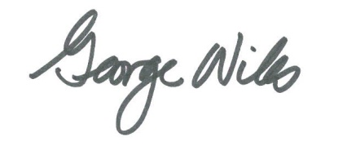

George A. Wiles, A.I.A.

APPENDIX “A” – CHFA Assessment Excerpts

CHFA Capital Plan Property Assessment - Stern Village

Current operations at the property are projected to generate roughly $121,800 in net operating income (NOI, or revenue after operating expenses) in Year 1 (2014). With incomes and expenses trending at 2% and 3% respectively, which is a standard affordable housing industry convention, the NOI figure decreases annually and results in negative NOI beginning in 2026. As a result, the property is not sustainable and cannot adequately address its future basic capital needs, projected to be approximately $4.32 million ($19,437 per unit) over the next 20 years.

The Stern Village property has 136 efficiency or studio and 86 one-bedroom units. Generally, the property consists of relatively small units.

The owner should note, however, that the rental income is not projected to meet the property's expenses over the next 20 years and may
struggle to cover future capital needs. The owner may want to consider an adjustment in the property's base rent in order to avoid future budget problems.

At this time, the "Current Scenario" is the only approach which reasonably covers the property’s capital and operating needs given
the current programmatic assumptions. However, it is neither a sustainable nor an efficient strategy as it requires the State to have a much more active role in supervising both capital and operating budgets.

This property does not have a stable operating revenue and expense picture and is at-risk of experiencing long term structural operating deficits unless it is able to access significant operating subsidy. Under the Current scenario, the property yields $121,814 in NOI in the current year, which includes $947 per unit per year in replacement reserve deposits, trending to negative $48,075 fifteen years thereafter. The transaction results in $474,000 in operating deficit subsidy, which would need to be covered by State capital subsidy. Given that the "Current Scenario" assumes a heavy dependence on state subsidy on an ongoing annual basis, any cash flow should presumably be escrowed to offset future subsidy need or to repay the state for prior subsidy payments.

CHFA Marketing Assessment

Challenges
• Small unit sizes compared to market, particularly 1 BR
• Majority of units are studios
• Stern Village consists of several older phases (1972, 1975)

b. Recommendations for Improving Marketability
Until recently, Stern Village represented the only established affordable housing in town, for seniors or non-seniors. That changed in 2006 with the addition of the 40-unit Huntington Place serving seniors. Despite the addition Huntington Place and the relatively large size of Stern Village, interest remains strong for units at Stern Village in a town with few affordable options. The two marketing drawbacks to the complex are the small size of the units – particularly the one bedroom - and the concentration in studio units. Short of a major reconstruction project to convert studios to 1 BRs, it is believed that marketability and rent
potential could be best augmented through a program of updating units, if not done already, that includes adding new features (dishwasher for example) and enhancing the energy efficiency of the buildings.

CHFA Capital Plan Assessment – Stern Village
CHFA Marketing Assessment
AARP Public Policy Institute

